**Setting Up Application Environment**

Install IBM Cloud CLI

|  |  |
| --- | --- |
| Date | 31-10-2022 |
| Team ID | PNT2022TMID31805 |
| Project Name | Personal Expense Tracker Application |

**Step 1:**

Login with your IBM Cloud https://cloud.ibm.com/login and in search bar you can type container registry and click to get started.

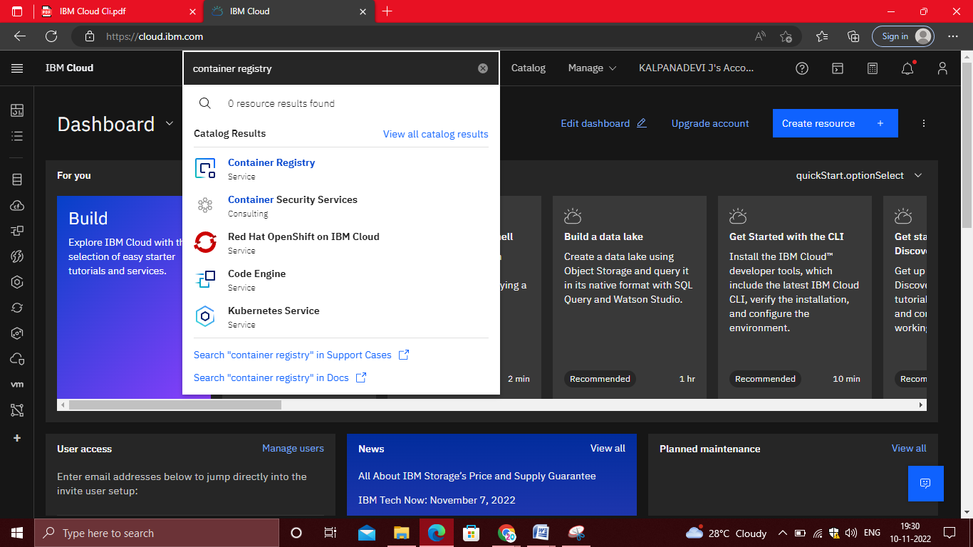

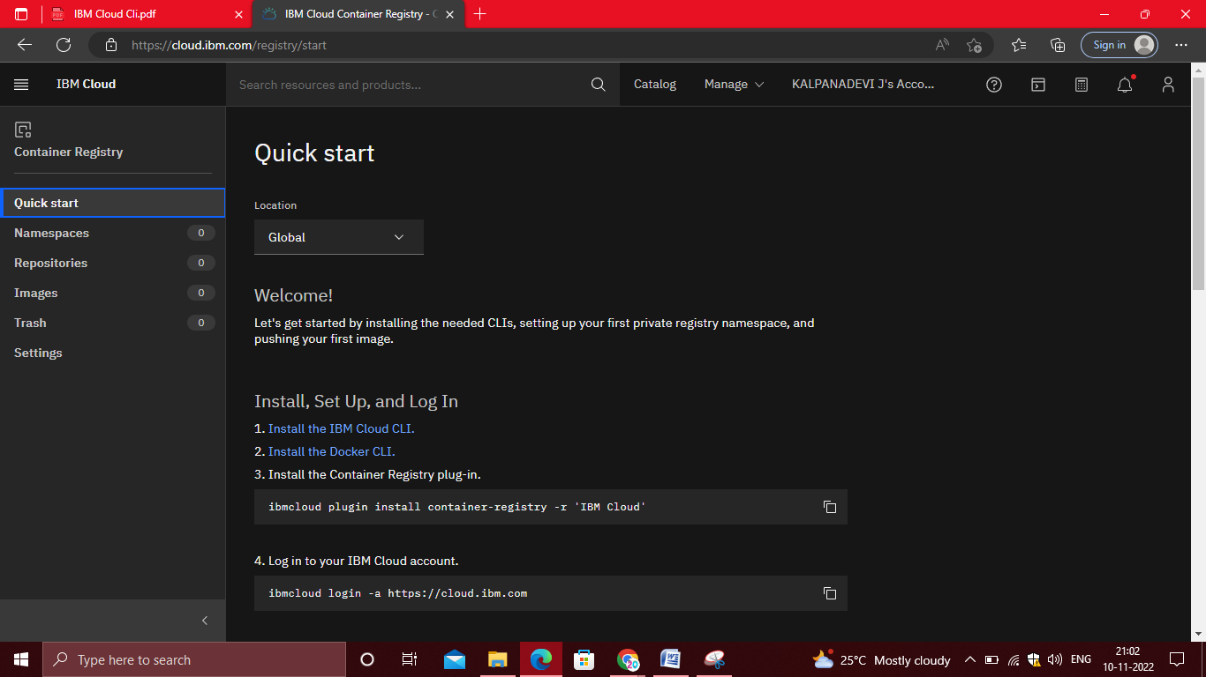

**Step 2:**

Follow and do the step given in this page one by one

<https://cloud.ibm.com/registry/start>

**Step 3:**

Run the command in power shell, (New-Object Net.WebClient).DownloadString('https://clis.cloud.ibm.com /install/powershell')

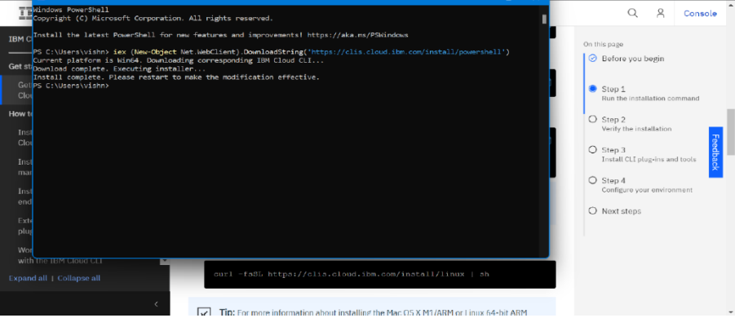

**Step 4:**

Enter the command in

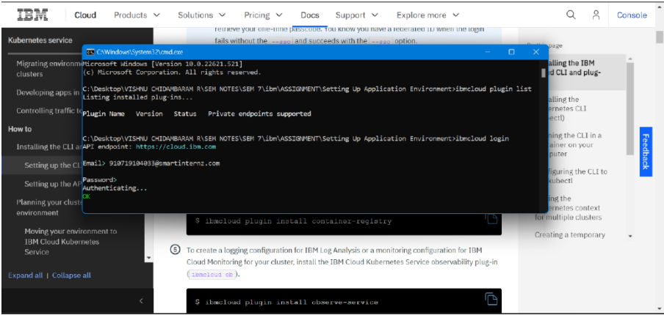

**Step 5:**

Run all the command one by one in command <https://cloud.ibm.com/docs/containers?topic=containers-cs_cli_install>

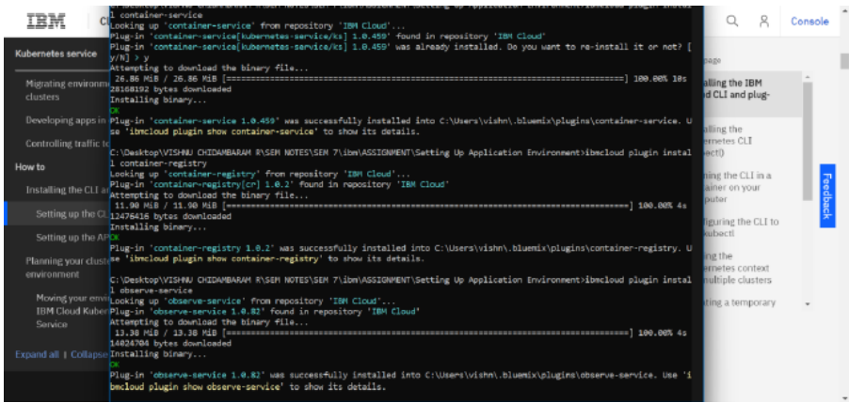

**Step 6:**

Finally, you will get the IBM CLOUD CLI in your desktop